School of Engineering, Applied Sciences, and Technology

BCS 202 Introduction to Computer Science II - SWS 316 Programming II

Project

Course Learning Outcomes | Project
CLO1. Demonstrate knowledge of the principles of Object-Oriented Programming | X | Q&A
CLO2: Apply the concepts of inheritance, polymorphism, interfaces and abstract classes to build efficient, muli-class applications.
CLO3: Code robust programs involving different data structures and exception handling constructs. | X | Code & Report
CLO4: Implement programs involving different data streams and file I/O.

Team Members
ID | Student Name | Q&A / 10 | Code & Report / 10 | Total / 20
202300037989 | Yasmin Issa
20220002536 | Maryam Al- Yaseen
20230003378 | Fasmin Nizar
20230003626 | Sidra Sheikh
20220001971 | Sulafa Duodi

Project Description and Requirements
You are asked to implement the below tasks, attach the code, and the screen shots that prove that your solution cover all test cases.

Rubric
Criterion | Needs Improvement  [0-3] | Good  [4-6] | Excellent  [7-10]
Q&A | The student provided poor answers and insufficient evidence of contribution to the assignment. | The student answered some of the questions correctly and showed some contribution to the assignment. | The student answered all questions correctly and showed genuine contribution to the assignment.

Criterion | Needs Improvement  [0-3] | Good  [4-6] | Excellent  [7-10]
Coding & Report | The code does not work properly, many requirements are missing, and the report does not provide enough proofs (screenshots) of testing scenarios. | The code works partially and implements some of the requirements; the report shows some testing scenarios. | The code works fully and as expected per the requirements and the report shows all testing scenarios.

Submission Instructions
- This is a group-based assignment (max of 5 members).
- The project consists of two parts: Coding & Reporting part and Q&A session.
- Choose only one project to implement.
- Coding and Reporting Part:
  - Your code should work.
  - It should contain embedded comments.
  - You should cover all test cases.
  - You should provide screen shots of the output.
- Q&A Part:
  - Each student will be asked individually.
  - The questions cover theory and practice of the project.
- Use this template for your final submission. Fill out the names of students on the front page.
- Attach your report to the end of this document (copy and paste).

Project Description:
For this project, students are encouraged to develop their own unique Java application, demonstrating their creativity and problem-solving skills. The application should address a specific problem or cater to a particular need within any domain of their choice, such as finance, healthcare, education, entertainment, or social networking. The project must incorporate the following key concepts:
- Java Basics, Arrays, and Strings:
  - Utilize arrays and strings for efficient data handling and manipulation within the application.
- Classes, Inheritance, Abstraction, and Interfaces:
  - Design classes with appropriate attributes and methods. Implement inheritance, abstraction, and interfaces where applicable to enhance the application's structure and flexibility.
- Exception Handling:
  - Implement robust exception handling mechanisms to handle errors gracefully and ensure a seamless user experience.
- File Handling:
  - Utilize file handling techniques to persistently store and retrieve data, allowing the application to maintain user information or application states across sessions.

Project Requirements:
- Innovative Concept: Choose an innovative and practical concept for the application. The idea should demonstrate the student's creativity and problem-solving abilities.
- Functionality: Implement core features relevant to the chosen domain. This could involve user interactions, data processing, calculations, simulations, or any other functionality that adds value to the application.
- User Interface (console): Design an intuitive and user-friendly interface if the application involves user interactions. Consider usability, aesthetics, and user experience to enhance the application's appeal.
- Exception Handling: Implement comprehensive error handling mechanisms to anticipate and manage unexpected scenarios, ensuring the application's stability and user satisfaction.
- File Handling: Implement file handling to store and retrieve data persistently. This could include user preferences, application settings, or any other relevant information crucial for the application's functionality.

Project 1: Student Gradebook Application

Project Description:
In this project, students will create a Student Gradebook Application using Java. The application should allow teachers to add students, assign grades for various subjects, calculate average grades, and generate reports. The project must incorporate Java basics, arrays, strings, classes, inheritance, abstraction, interfaces, exception handling, and file handling concepts.

Project Requirements:
- Implement classes for students and subjects.
- Allow teachers to add students and assign grades for different subjects.
- Calculate and display average grades for each student.
- Generate a report with student names, subject-wise grades, and average grades.
- Store and retrieve student data using file handling.

Requirements:
- Functionality
  - Proper implementation of student addition, grade assignment, average calculation, and report generation functionality.
  - Correct handling of exceptions and input validation.
  - Effective use of file handling for data storage and retrieval.
- Object-Oriented Concepts
  - Proper use of classes, inheritance, abstraction, and interfaces.
  - Clear organization of code and separation of concerns.
- User Interface and Experience
  - User-friendly interface with clear prompts and instructions.
  - Intuitive user interactions for tasks like grade assignment and report generation.
- Code Quality and Readability
  - Consistent coding style, proper indentation, and meaningful variable/method names.
  - Comments and documentation explaining complex logic or algorithms.

The following project is a Student Grading System developed using Java, utilizing various Java features such as methods, inputs, lists, inheritance, and interfaces. The implementation comprises four classes namely, Student, Subject, Gradebook and an interface along with the class Main to test the functionality of the project. This project takes the students' information like name, major, subject, grades as an input using the Scanner and then stores it in files through File Handling. Our project also calculates the average for each student in the list and stores it into a variable. Lastly to ensure that the application is protected from the invalid inputs and other errors that can occur when using the program Using Exception Handling.

MAIN CODE:
import java.io.IOException;
import java.util.InputMismatchException;
import java.util.Scanner;

public class GradebookApp {
public static void main(String[] args) {
Gradebook g1 = new Gradebook();
Scanner scan = new Scanner(System.in);
int choice = 0;

// Load data from the file at the beginning
try {
g1.loadData();
} catch (Exception e) {
System.out.println("An error occurred while loading data: " + e.getMessage());
}

while (choice != 5) {
System.out.println("Enter choice:");
System.out.println("1. Add student");
System.out.println("2. Assign Grade");
System.out.println("3. Generate Report");
System.out.println("4. Delete Student");
System.out.println("5. Exit");

try {
choice = scan.nextInt();
scan.nextLine(); // Consumes newline
} catch (InputMismatchException e) {
System.out.println("Invalid input. Please enter a number between 1 and 5.");
scan.nextLine(); // Clear the invalid input
continue;
}

try {
switch (choice) {
case 1:
try {
System.out.println("Enter student name:");
String studentName = scan.nextLine();
if (studentName.isEmpty()) {
throw new IllegalArgumentException("Student name cannot be empty.");
}
Student student = new Student(studentName);
g1.addStudent(student);
g1.writeData();
System.out.println("Student Added Successfully");
} catch (IOException e) {
System.out.println("An error occurred while writing data: " + e.getMessage());
} catch (IllegalArgumentException e) {
System.out.println(e.getMessage());
} catch (Exception e) {
System.out.println("An unexpected error occurred: " + e.getMessage());
}
break;
case 2:
try {
System.out.println("Enter Student's Name:");
String name = scan.nextLine();
if (name.isEmpty()) {
throw new IllegalArgumentException(
"Student name cannot be empty, please enter the student's name.");
}
System.out.println("Enter Subject:");
String subject = scan.nextLine();
if (subject.isEmpty()) {
throw new IllegalArgumentException("Subject cannot be empty, please enter a subject.");
} // Exception of improper input type
System.out.println("Enter Grade:");
if (!scan.hasNextDouble()) {
throw new IllegalArgumentException(
"Grade cannot be empty, please enter a value for the grade.");
} // Exception of improper input type
double grade = scan.nextDouble();
scan.nextLine(); // Consume newline
if (grade < 0 || grade > 100) {
throw new IllegalArgumentException("Grade must be between 0 and 100.");
} // Exception of improper input type
Student s = g1.findStudentByName(name);
if (s != null) {
g1.assignGrade(s, subject, grade);
g1.writeData();
} else {
System.out.println("Student not found.");
}
} catch (IOException e) {
System.out.println("An error occurred while writing data: " + e.getMessage());
} catch (IllegalArgumentException e) {
System.out.println(e.getMessage());
} catch (Exception e) {
System.out.println("An error occurred: " + e.getMessage());
}
break;
case 3:
try {
g1.generateReport();
} catch (Exception e) {
System.out.println("An error occurred while generating the report: " + e.getMessage());
}
break;
case 4:
try {
System.out.println("Enter Student's Name to delete:");
String nameToDelete = scan.nextLine();
g1.deleteStudent(nameToDelete);
g1.writeData();
System.out.print("Student deleted successfully.");
} catch (IOException e) {
System.out.print("An error occurred while writing data: " + e.getMessage());
} catch (Exception e) {
System.out.print("An error occurred: " + e.getMessage());
}
break;
case 5:
System.out.println("Exiting...");
break;
default:
System.out.println("Invalid choice. Please choose between 1-5.");
}
} catch (Exception e) {
System.out.println("An error occurred: " + e.getMessage());
}
}
scan.close();
}

}

GradeBook Class
import java.io.File;
import java.io.FileWriter; // Importing file manipulating.
import java.io.IOException; // Importing to detect input/output Exceptions.
import java.util.ArrayList; // Importing allowing the usage of marking and manipulating array lists.
import java.util.List;
import java.util.Scanner; // Importing scanner to allow the reading of user input.

public class Gradebook {
private List<Student> students;
private static final String FILENAME = "gradebook.txt";

public Gradebook() {
students = new ArrayList<>();
}

public void addStudent(Student student) {
students.add(student);
}

public void deleteStudent(String name) {
for (int i = 0; i < students.size(); i++) { // For i in the list of students, it keeps iterating through until
// it finds the student to be deleted and deletes them and their
// respective information.
Student student = students.get(i);
if (student.getName().equalsIgnoreCase(name)) {
students.remove(i);
return; // Exit the method after removing the student
}
}
}

public void assignGrade(Student student, String subject, double grade) {
student.addGrade(subject, grade);
}

public void generateReport() {
for (Student student : students) {
System.out.println("Student: " + student.getName());
System.out.println("Grades: " + student.getGradesAsString());
System.out.println("Average: " + student.getcalculateAverage());
}
}

public void writeData() throws IOException {
try (FileWriter writer = new FileWriter(FILENAME)) {
for (Student student : students) {
writer.write(student.getName() + "," + student.getGradesAsString() + " Average: "
+ student.getcalculateAverage() + "\n");
}
} catch (IOException e) {
throw new IOException("An error occurred while writing data to the file: " + e.getMessage());
}
}

public void loadData() throws IOException {
File file = new File(FILENAME);
if (!file.exists()) {
System.out.println("FILE IS EMPTY"); // No data to load
}

try (Scanner fileScanner = new Scanner(file)) {
while (fileScanner.hasNextLine()) {
String line = fileScanner.nextLine();
String[] parts = line.split(",", 2); // The first one specifies where the first parameter ends (in this
// case when there is a ,)
if (parts.length == 2) { // Second part shows that it is only split into 2, meaning in this case it is
// split to the name and the grades.
String studentName = parts[0];
String gradesStr = parts[1];
Student student = new Student(studentName);

String[] gradeEntries = gradesStr.split(",");
for (String gradeEntry : gradeEntries) {
String[] gradeParts = gradeEntry.trim().split(":");
if (gradeParts.length == 2) {
String subject = gradeParts[0].trim();
double grade = Double.parseDouble(gradeParts[1].trim());
student.addGrade(subject, grade);
}
}
students.add(student);
}
}
} catch (IOException e) {
throw new IOException("An error occurred while loading data from the file: " + e.getMessage());
}
}

public Student findStudentByName(String name) {
for (Student student : students) {
if (student.getName().equalsIgnoreCase(name)) {
return student;
}
}
return null;
}
}

Student Class
import java.util.ArrayList;
import java.util.List;

public class Student extends Gradebook {
private String name;
private List<Grade> grades;// list of grades of type Grade

public Student(String name) {
this.name = name;
this.grades = new ArrayList<>();
}

public void addGrade(String subject, double grade) {
if (subject == null || subject.isEmpty()) {
throw new IllegalArgumentException("Subject cannot be empty.");
}
if (grade < 0 || grade > 100) {
throw new IllegalArgumentException("Grade must be between 0 and 100.");
}
grades.add(new Grade(subject, grade));
}

public String getName() {
return name;
}

public List<Grade> getGrades() {
return grades;
}

public String getGradesAsString() {// same function as .toString (just different naming to clear the air and show
// that this is for grades)
StringBuilder sb = new StringBuilder();
for (Grade grade : grades) {
sb.append(grade.getSubject()).append(":").append(grade.getGrade()).append(",");
}
if (sb.length() > 0) {
sb.setLength(sb.length() - 1);
}
return sb.toString();
}

public double getcalculateAverage() {
if (grades.isEmpty()) {
return 0;
}
double sum = 0;
for (Grade grade : grades) {
sum += grade.getGrade();
}
return sum / grades.size();
}

private static class Grade {
private String subject;
private double grade;

public Grade(String subject, double grade) {
this.subject = subject;
this.grade = grade;
}

public String getSubject() {
return subject;
}

public double getGrade() {
return grade;
}

@Override
public String toString() {
return subject + ": " + grade;
}
}
}

Subject Class
public class Subject { //a class to enable the calling of the subject's name.
private String subName;

public Subject() {
}

public Subject(String name) {
this.subName = name;
}

public String getsubName() {
return this.subName;
}
}

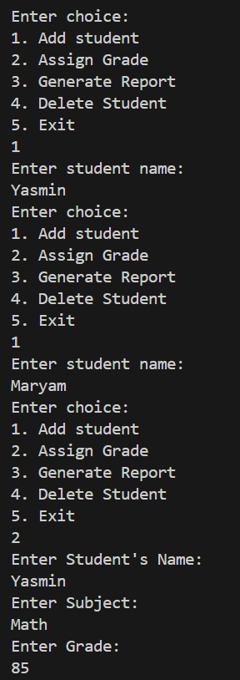
OUTPUT:
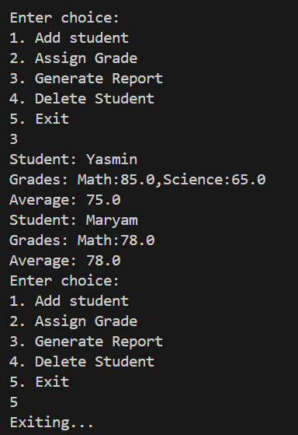
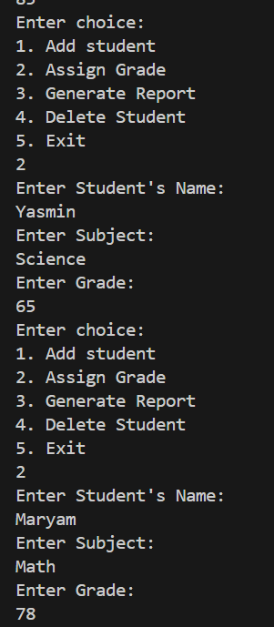

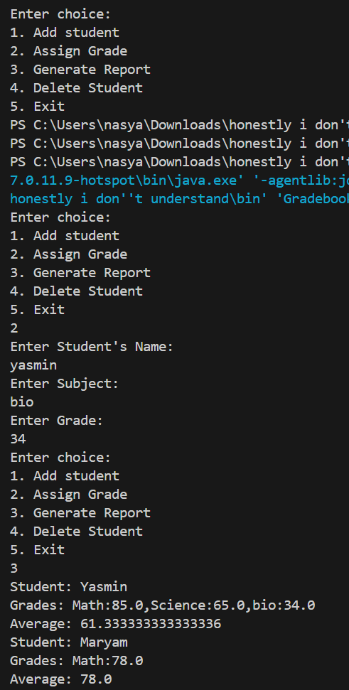

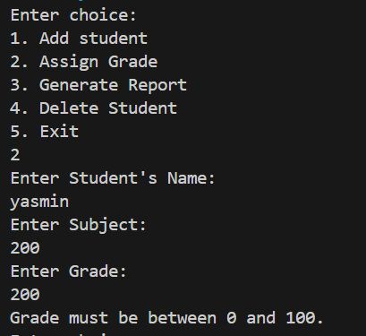

Files Attached:

